
Sukkur Institute of Business Administration University
Department of Computer Science
BS – I (CS/SE) Fall 2025

Programming Fundamentals
Lab # 03: To become familiar with type conversation and <iomanip> library and Arithmetic Operator

Lab Report Rubrics  (Add the points in each column, then add across the bottom row to find the total score) |  |  |  |  | Total Marks
S.No | Criterion | 0.5 | 0.25 | 0.125
1 | Accuracy | - Desired output | - Minor mistakes | - Critical mistakes
2 | Timing | - Submitted within the given time | - 1 day late | - More than 1 day late
Submission Profile
Name: Submission date (dd/mm/yy):
Enrollment ID: Receiving authority name and signature:
Comments: __________________________________________________________________________
Instructor Signature

Note: Submit this lab hand-out in the next lab with attached solved activities and exercises

Objectives
After performing this lab, students will be able to
- Type conversion
- <iomanip> library for formatting output
- setw, setprecision, fixed, left, right
- Format floating-point numbers with respect to decimal places.
- Arithmetic Operator

Type conversion
C++ allows us to convert data of one type to that of another. This is known as type conversion. There are two types of type conversion in C++.
- Implicit Conversion
- Explicit Conversion (also known as Type Casting)

Implicit Type Conversion
The type conversion that is done automatically by the compiler is known as implicit type conversion. This type of conversion is also known as automatic conversion.
Let us look at two examples of implicit type conversion.

Example 1: Conversion From int to double
// Working of implicit type-conversion
#include <iostream>
using namespace std;
int main() {
// assigning an int value to num_int
int num_int = 9;
// declaring a double type variable
double num_double;
// implicit conversion
// assigning int value to a double variable
num_double = num_int;
cout << "num_int = " << num_int << endl;
cout << "num_double = " << num_double << endl;
return 0;}

Output:
num_int = 9
num_double = 9
In this program, we have assigned an int data to a double variable. Here, the int value is automatically converted to double by the compiler before it is assigned to the num_double variable. This is an example of implicit type conversion.

Example 2: Automatic Conversion from double to int
//Working of Implicit type-conversion
#include <iostream>
using namespace std;
int main() {
int num_int;
double num_double = 9.99;
// implicit conversion
// assigning a double value to an int variable
num_int = num_double;
cout << "num_int = " << num_int << endl;
cout << "num_double = " << num_double << endl;
return 0;
}

Output:
num_int = 9
num_double = 9.99
In this program, we have assigned a double data to an int variable. Here, the double value is automatically converted to int by the compiler before it is assigned to the num_int variable. This is also an example of implicit type conversion.
Note: Since int cannot have a decimal part, the digits after the decimal point is truncated/removed in the above example.

Data Loss During Conversion (Narrowing Conversion)
As we have seen from the above example, conversion from one data type to another is prone to data loss. This happens when data of a larger type is converted to data of a smaller type.

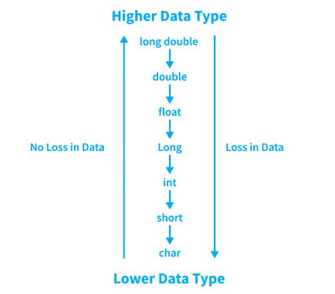

C++ Explicit Conversion
When the user manually changes data from one type to another, this is known as explicit conversion. This type of conversion is also known as type casting.
Following are the major ways in which we can use explicit conversion in C++:
- C-style type casting (also known as cast notation)
- Function notation (also known as old C++ style type casting)

C-style Type Casting
As the name suggests, this type of casting is favored by the C programming language. It is also known as cast notation. The syntax for this style is:
(data_type)expression;
For example:
// initializing int variable
int num_int = 26;
// declaring double variable
double num_double;
// converting from int to double
num_double = (double)num_int;

Function-style Casting
We can also use the function like notation to cast data from one type to another. The syntax for this style is:
data_type(expression);
For example
// initializing int variable
int num_int = 26;
// declaring double variable
double num_double;
// converting from int to double
num_double = double(num_int);

Example 3: Type Casting
#include <iostream>
using namespace std;
int main() {
// initializing a double variable
double num_double = 3.56;
cout << "num_double = " << num_double << endl;
// C-style conversion from double to int
int num_int1 = (int)num_double;
cout << "num_int1 = " << num_int1 << endl;
// function-style conversion from double to int
int num_int2 = int(num_double);
cout << "num_int2 = " << num_int2 << endl;
return 0;}

Output
num_double = 3.56
num_int1 = 3
num_int2 = 3
We used both the C style type conversion and the function-style casting for type conversion and displayed the results. Since they perform the same task, both give us the same output.

<iomanip>
The <iomanip> library in C++ provides a set of tools to manipulate and control the formatting of output. It's particularly useful when you want to control how numeric values are displayed, including controlling the number of decimal places, width, alignment, and more. It stands for "input/output manipulation".
Here are some common formatting manipulators and functions provided by the <iomanip> library:
setw(n): This manipulator sets the width of the output field. It's particularly useful for aligning output.
endl: This manipulator is used to end a line of output and flush the output buffer.
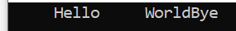
left and right: These manipulators set the alignment of output to the left or right side of the output field.



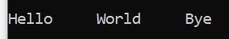

setprecision(n): This manipulator sets the number of decimal places to be displayed for floating-point numbers.
fixed: This manipulator forces floating-point numbers to be displayed in fixed-point notation (i.e., a fixed number of decimal places).
scientific: This manipulator displays floating-point numbers in scientific notation.

Example:
#include <iostream>
#include <iomanip> // Include the iomanip library
using namespace std;
int main() {
// Display the value with exactly two decimal places
cout << fixed << setprecision(2) << 12.84890 << endl;
// value in scientific notation exactly two decimal places
cout << scientific << setprecision(2) << 12.84890 << endl;

return 0;

system("PAUSE");

}

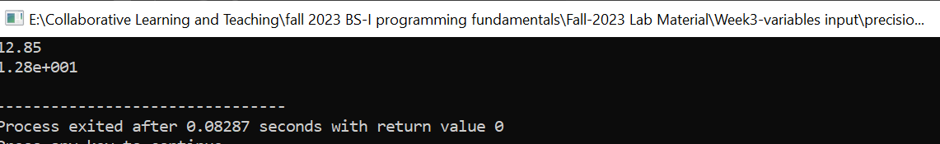

setfill(): This manipulator takes an argument of type char and sets the specified character as the fill character for the output stream. The fill character is used to pad the output when the printed data is narrower than the specified field width.
Example:
#include <iostream>
#include <iomanip>
int main() {
using namespace std;
int number = 1947;
cout<< "Default fill: {" << number << "}" <<endl;
cout<<setfill('$');
cout<< "Fill the spaces with '$': (" <<setw(10) << number << ")" <<endl;
cout<<setfill('@');
cout<< "Fill the spaces with '@': [" <<setw(10) << number << "]" <<endl;
return 0;
}

Output:

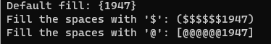

C++ Operators
An operator is a symbol used for performing operations on operands. Operands can be literal values or variables.
Consider the following operation:
a = x + y;
In the above statement, x and y are the operands while + is an addition operator. When the C++ compiler encounters the above statement, it will add x and y and store the result in variable a.
Operators in C++ can be classified into different types, like:
- Arithmetic Operators
- Assignment Operators
- Relational Operators
- Logical Operators
- Bitwise Operators

Arithmetic Operators
Arithmetic operators are used to perform arithmetic/mathematical operations on variables and data. For example: a + b;
Here, the + operator is used to add two variables a and b. Similarly, there are various other arithmetic operators in C++.

Operator | Operation
+ | Addition
- | Subtraction
* | Multiplication
/ | Division
% | Modulo Operation (gives remainder after division)

Example 1: Arithmetic Operators

#include <iostream>
using namespace std;

int main() {
int a, b;
a = 7;
b = 2;

// printing the sum of a and b
cout << "a + b = " << (a + b) << endl;

// printing the difference of a and b
cout << "a - b = " << (a - b) << endl;

// printing the product of a and b
cout << "a * b = " << (a * b) << endl;

// printing the division of a by b
cout << "a / b = " << (a / b) << endl;

// printing the modulo of a by b
cout << "a % b = " << (a % b) << endl;

return 0;}

Output
a + b = 9
a - b = 5
a * b = 14
a / b = 3
a % b = 1
Here, the operators +, - and * compute addition, subtraction, and multiplication respectively as we might have expected.

A note about the division operator /
Note the operation (a / b) in our program. The / operator is the division operator. As we can see from the above example, if an integer is divided by another integer, we will get the quotient.
However, if either divisor or dividend is a floating-point number, we will get the result in decimals.
In C++
7/2 is 3
7.0 / 2 is 3.5
7 / 2.0 is 3.5
7.0 / 2.0 is 3.5

% Modulo Operator
The modulo operator % computes the remainder. When a = 9 is divided by b = 4, the remainder is 1.
Note: The % operator can only be used with integers.

Practice Task: 1
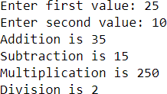
Write a C++ program that asks user to input two integer values and then performs the addition, subtraction, multiplication, and division on those values. Something like shown below:

Solution
#include <iostream>
using namespace std;
int main() {
int num1;
int num2;
cout << "Enter first number: ";
cin >> num1;
cout << "Enter second number: ";
cin >> num2;
cout << "Addition is " << num1+num2 << endl;
cout << "Subtraction is " << num1-num2 << endl;
cout << "Multiplication is " << num1*num2 << endl;
cout << "Division is " <<num1/num2 << endl;
return 0;
}

Practice Task: 2
Make some changes in the program written in the Activity above so that the output should be like the following
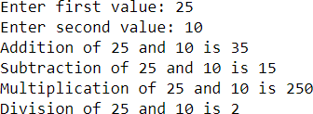
#include <iostream>
using namespace std;
int main() {
int num1;
int num2;

cout << "Enter first number: ";
cin >> num1;

cout << "Enter second number: ";
cin >> num2;
endl;
cout << "Addition of " << num1 << " and " << num2 << " is " << num1+num2 << endl;
cout << "Subtraction of " << num1 << " and " << num2 << " is " << num1-num2 << endl;
cout << "Multiplication of " << num1 << " and " << num2 << " is " << num1*num2 <<endl;
cout << "Division of " << num1 << " and " << num2 << " is " << num1/num2 << endl;
return 0;
}

Exercises

- Write a program that generates the following output by using setw, left, right and endl manipulators.
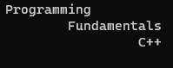
- Write a program to print the following shapes using the setw and endl manipulator only(Don’t use and escape sequence or spaces).
Hint: setw only affects the immediately following output. It doesn't persist for subsequent outputs.
a. | 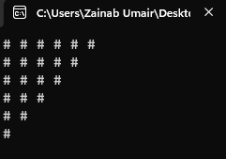 | b. | 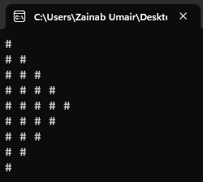
c. | 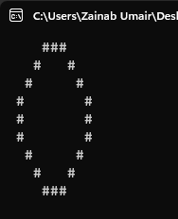 | d. | 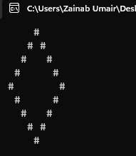

- Write a program that asks the user to input two numbers i.e., num1 and num2;
And the output should be formatted according to these numbers. The larger number will print the larger gap on the screen (use setw and right align).

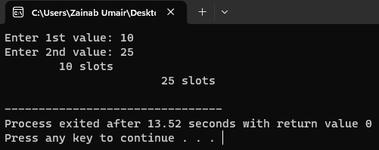
- Generate the below-mentioned output using the Manipulators only (setw(n), endl, fixed, left, etc.)
Hint: You may use setprecision(n), left/right, and fixed only once in a program. No need to use them again and again.

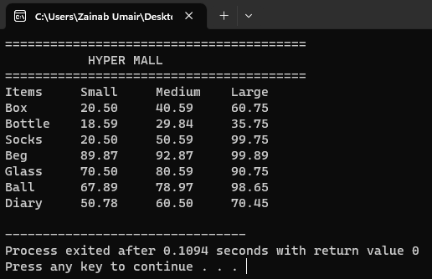

- Write a program in which you create three float variables to set the price of 240.99999 for a joystick, 180.88888 for disk, and 570.77777 for keyboard. Your task is to print the prices of the above-mentioned items in the following format.
NOTE: After decimal points, your program must print two digits.

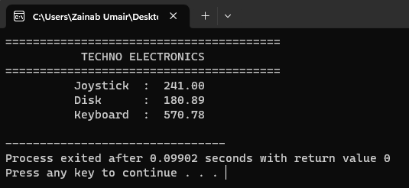

- Make a program in which it asks form user to enter total amount, you have to answer how much INTEREST to be paid on that amount. INTEREST is the 14.5% of the total amount.
Hint: In order to calculate the INTEREST of 14.5% is (14.5/100*n), where n is the amount given by the user.

- Write a program for the marksheet, where user should be able to enter the marks for five subjects. Then, your program should tell him/her his/her obtained marks, average marks and percentage.
Note: You can assume each subject to be of 100 marks. So, the total marks would become 500 for five subjects. While printing the final Marksheet it must contain your name and CMS-ID as student name and CMS-ID.
The sample output is shown below (This is just a sample; you may even come up with new ideas to make marksheet look more eye-catching)
